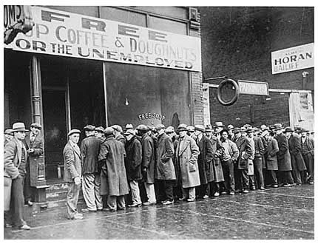
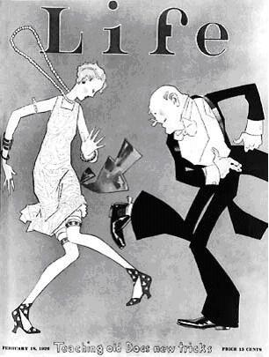
Australia between the Wars: 1920s-1030s
Australia experienced a time of immense change in between World War 1 and World War 2.
The 1920s were a decade of great prosperity. In the aftermath of the Great War, people were celebrating just being alive. Moreover, they had more money, now that they didn’t have to spend it on the war effort. Women’s roles were changing too. A growing number cut their hair short—their dresses even shorter and went out partying just like the boys. They were called flappers.

The 1930s were quite different. Following the stock market crash of 1929, many people were unemployed and struggled to make ends meet. After the decadence and affluence of the 1920s, the ‘30s were a real come-down. However, it wasn’t all doom and gloom. The Sydney Harbour Bridge was opened, Phar Lap won the Melbourne Cup and Donald Bradman was dominating the international cricket world. Australia was still largely influenced by British—and increasingly American—culture, but we were really starting to develop our own identity.

Your task this lesson:
- Use the internet and your text book to develop some background knowledge of this time period.
- Construct a timeline, that includes at least 12 key events from these decades
- On your timeline, you should include:
  - a brief description of the event
  - several images depicting that event
  - a statement about how that event contributed to Australia’s national identity between the wars
- You can construct your timeline in your workbook, using Word, Prezi, PowerPoint or other software

