Kokoda Research Project

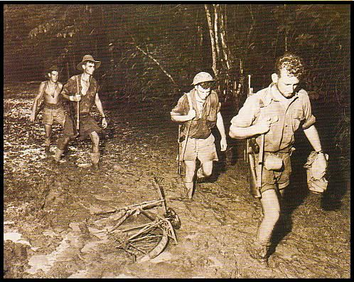
In Papua from July 1942 to January 1943 over 120,000 people from four regions fought, or supported the fighting troops...
The largest group were Australians, 56,000 of whom were at one time or another either in Papua or involved in air and sea operations there. The Americans, allied to the Australians, contributed 24,000 men. Their enemy the Japanese had 27,000 men, some not from Japan but from its empire, involved in Papuan operations. About 18,000 people from what is now Papua New Guinea, but was then the Australian Territories of Papua and New Guinea, fought, scouted and carried supplies for both sides.

Task 1: who was involved?
Read through the following country profiles and complete the table below.

The Australians
Australians from all states and territories served in Papua...
Several hundred of them were either born there or had worked there but the great majority came from mainland Australia as members of two branches of the Australian Military Forces; the Citizen Military Force and the Australian Imperial Force. The former was, from 1940, a part conscript, part volunteer force obliged to serve in Australia and its territories. The latter was an all volunteer force raised in 1939. About 1800 Australians served in the Royal Australian Air Force in operations relating to the Papuan campaign. The majority were based at airfields in far north Queensland. The Royal Australian Navy guarded the sea communications from Australia and maintained a coastal supply line from Port Moresby to Milne Bay and later along the north coast of Papua.

The New Guineans
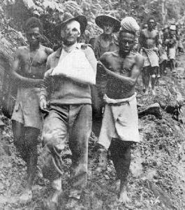
The great majority of New Guineans who participated in the campaign did so as carriers of supplies for the Allies, though 400 men from the Papuan Infantry Battalion and the Royal Papuan Constabulary fought against the Japanese in 1942... Two thousand men from New Britain worked for the Japanese as carriers and between two and three hundred Papuans aided the Japanese as armed scouts. The arrival of the Japanese intruded into tribal politics. Those of the Orokaiva, Bininderi and Koiari peoples, who were employed by the Australian administration at the start of the campaign, in the main sided with the Australians. Others had no particular reason to favour either side. Of necessity it was more important for them to consider the effect of the arrival of the Japanese on the web of political relations between tribal groups. Consequently some calculated it was in their best interest to support the new arrivals, especially if a local enemy had thrown in their lot with the Australians.

The Americans
No Americans fought on the Kokoda track but 24,000 participated in the Battle of Buna-Gona, at Milne Bay, or were involved in air and coastal operations... The major American formation present was the 32nd Division composed of National Guards, a militia force from the states of Michigan and Wisconsin. This division arrived in Australia in May 1942 and went into battle at Buna in November 1942. A regiment of 41st Division was engaged at Sanananda and United States Army engineers fought at Milne Bay and maintained communications and supply at Port Moresby. American anti-aircraft units also served at Port Moresby, Milne Bay and Buna.

The Japanese
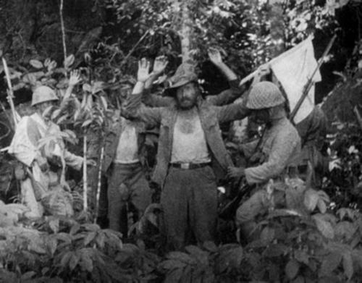
Like the Australians until late 1942, Imperial Japanese Army units tended to be recruited by region... During the Kokoda phase of the Papuan campaign the majority of the Japanese fighting troops were from the island of Shikoku or from the Hiroshima area. Later these were reinforced by troops mainly from Osaka. The Imperial Japanese Navy escorted shipping to Papua and was engaged in coastal operations. Two thousand of the Navy's marines served at Buna and Milne Bay. The IJN (Imperial Japanese Navy) also provided almost all of the aircraft supporting land operations from bases at Lae, Gasmata and Rabaul. Perhaps 2100 of the Japanese force in Papua were not from Japan. These men, primarily engaged in carrying ammunition and food, were from Korea, China and Taiwan.

 | New Guineans | Americans | Australians | Japanese
Why are you fighting in this war?
What will happen to you and your family if you lose the war?

How is the country your fighting in different from home?

How are your people different from the other people?
How do you feel about the enemy?

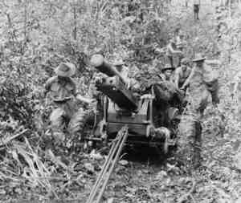
as we have discussed The battle of Kokoda was not an isolated battle but was a part of a series of skirmishes that lasted over a period of months from August 1942 – January 1943 in Papua New Guinea. As we have seen above, America became involved in the effort to force to Japanese out of Papua New Guinea after the Battle of Kokoda. Complete task 2 to figure out where the fighting happened and the tactics that were involved.
Task 2: where did the fighting happen?
Go to http://kokoda.commemoration.gov.au/battle-maps/battle-maps.php and click on the interactive battle maps to watch the animations.
- What were some of the key battles/skirmishes that took place in the battle for kokoda?

__________________________________________________________

__________________________________________________________

__________________________________________________________

__________________________________________________________

- What are some strategies that were used by either side during the fighting that took place in Papua New Guinea?

__________________________________________________________

__________________________________________________________

__________________________________________________________

__________________________________________________________
- Evaluate the significance of aircraft and artillery in the battles?
__________________________________________________________

__________________________________________________________

__________________________________________________________

__________________________________________________________

One of the reasons why kokoda was so important was because it was the first time in World War II in the Pacific Theatre that Japanese land forces were stopped. It was also important because if they took Port Moresby they could use Papua New Guinea as a landing base to invade Australia (if they wanted to – it is disputed as to whether or not Japan was going to invade Australia or not).
Task 3: why was kokoda so important (strategically)?
Go to http://kokoda.commemoration.gov.au/war-in-papua/index.php and read the text under The War in Papua: The Strategic Context. Also click on the tabs on the right hand of the page (Japanese intelligence about the kokoda track, why was port Moresby so important?, the war in the air, the war at sea).
What are some other reasons that the battle for Kokoda was so important according to the text?
_________________________________________________________________________
_________________________________________________________________________
_________________________________________________________________________
_________________________________________________________________________
_________________________________________________________________________
_________________________________________________________________________
_________________________________________________________________________
_________________________________________________________________________
_________________________________________________________________________
_________________________________________________________________________
_________________________________________________________________________
_________________________________________________________________________
_________________________________________________________________________
_________________________________________________________________________
_________________________________________________________________________
_________________________________________________________________________
_________________________________________________________________________
_________________________________________________________________________
_________________________________________________________________________
_________________________________________________________________________
_________________________________________________________________________

Over 56,000 australians served in the Papuan campaign in the army, airforce, navy or auxiliary services. Some were never to return home, others would bring back memories that would be scarred for life or return home wounded with physical disability.
Task 4: Australian veterans accounts
Go to http://kokoda.commemoration.gov.au/australian-veterans-accounts/veterans-accounts.php and listen to three of the veterans interviews and answer the following questions.

Veteran 1
Name: ______________________________________________________________
Gender: ____________________________________________________________
Service (e.g. 39th infantry battalion, 2/9th Australian general hospital):
_____________________________________________________________________
What do we learn about the living/fighting conditions faced by people at the time?
_____________________________________________________________________
_____________________________________________________________________
_____________________________________________________________________
_____________________________________________________________________

How do you feel when you watch the interview? How do you think the veteran feels as they recall the events?
_____________________________________________________________________
_____________________________________________________________________
_____________________________________________________________________
_____________________________________________________________________
_____________________________________________________________________

Veteran 2
Name: ______________________________________________________________
Gender: ____________________________________________________________
Service (e.g. 39th infantry battalion, 2/9th Australian general hospital):
_____________________________________________________________________
What do we learn about the living/fighting conditions faced by people at the time?
_____________________________________________________________________
_____________________________________________________________________
_____________________________________________________________________
_____________________________________________________________________

How do you feel when you watch the interview? How do you think the veteran feels as they recall the events?
_____________________________________________________________________
_____________________________________________________________________
_____________________________________________________________________
_____________________________________________________________________
_____________________________________________________________________

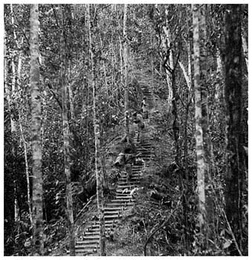
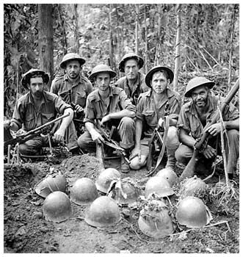

Veteran 3
Name: ______________________________________________________________
Gender: ____________________________________________________________
Service (e.g. 39th infantry battalion, 2/9th Australian general hospital):
_____________________________________________________________________
What do we learn about the living/fighting conditions faced by people at the time?
_____________________________________________________________________
_____________________________________________________________________
_____________________________________________________________________
_____________________________________________________________________

How do you feel when you watch the interview? How do you think the veteran feels as they recall the events?
_____________________________________________________________________
_____________________________________________________________________
_____________________________________________________________________
_____________________________________________________________________
_____________________________________________________________________

