Intro:

Today looking at 2 events:
- Jap Sub attack Syd Harbour
- Bombing of Darwin
Discuss connection between Kokoda and Japanese invasion.
Attacks were before Kokoda! Jap sub attacks May 1942 – Darwin Bombed Feb 1942 - Kokoda July 1942.

Read text book together on Darwin.

Watch a clip from Australia (2008) showing the bombing of Darwin.

Go to http://ww2australia.gov.au/underattack/sydharbour.html , read the text and answer the following questions:
- What weapons did the Japanese use to attack Sydney Harbour?
  - Midget Subs sent from mother subs.
- What was the Japanese objective of the attack upon Sydney Harbour?
  - To sink the heavy cruiser USS Chicago but also sink shipping.
- What did the Japanese attack achieve?
  - The sinking of the HMAS Kattabul, the death of 19 Australians and 2 British soldiers.
- What happened to each three of the Japanese Midget Submarines and their motherships?
  - Motherships attacked shipping along the coast. 2 midgets committed suicide. One tried to reunite with mothership.
- How did the Australian Government use the attack on Sydney Harbour to raise money for the war?
  - Pay to see the Japanese Submarines – total war.
- What did the Australians do with the dead bodies of the Japanese submariners? Why did Rear Admiral Muirhead-Gould do this? Why was this controversial with the Australian people?
  - Full military burial in the hope that Aust prisoners of war would be well treated.
- How do you think the Japanese attack on Sydney Harbour affected the morale/feelings of the Australian public?

Go through photo gallery and watch videos together from http://ww2australia.gov.au/underattack/sydharbour.html
Japanese Raid on Sydney Harbour
Go to http://ww2australia.gov.au/underattack/sydharbour.html , read the text and answer the following questions:
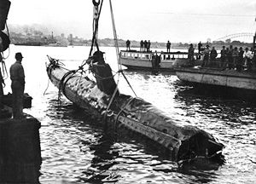
- What weapons did the Japanese use to attack Sydney Harbour?

- What was the Japanese objective of the attack upon Sydney Harbour?

- What did the Japanese attack achieve? Did it meet its objective/s? Why/Why not?

- What happened to each three of the Japanese Midget Submarines and their motherships?

- How did the Australian Government use the attack on Sydney Harbour to raise money for the war?

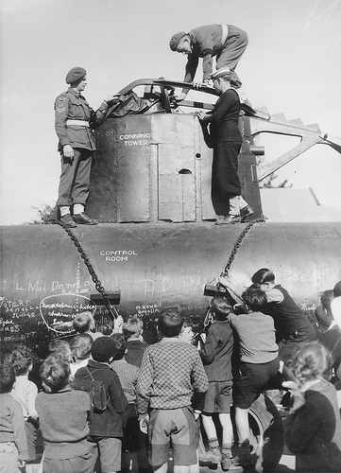

- What did the Australians do with the dead bodies of the Japanese submariners? Why did Rear Admiral Muirhead-Gould do this? Why was this controversial with the Australian people?

- How do you think the Japanese attack on Sydney Harbour affected the morale/feelings of the Australian public?

